Overview
Alex (Agentic Learning Equities eXplainer) is a multi-agent enterprise-grade SaaS financial planning platform/product that provides insights on users' equity portfolios through reports and charts. Alex is integrated with Clerk for user management, and the database architecture keeps user data separate.

Agent Responsibilities
Financial Planner (Orchestrator)
Role: Master coordinator that manages the entire analysis workflow
- Receives user requests for portfolio analysis
- Identifies missing instrument data and delegates to InstrumentTagger
- Coordinates all specialized agents
- Retrieves relevant context from S3 Vectors knowledge base
- Compiles final analysis from all agent outputs
- Updates job status throughout the process
InstrumentTagger
Role: Automatically populate reference data for financial instruments
- Classifies instruments by asset class (equity, fixed income, etc.)
- Determines regional allocation (North America, Europe, Asia, etc.)
- Identifies sector exposure (technology, healthcare, financials, etc.)
- Uses Structured Outputs for consistent data format
- Future: Will integrate with Polygon API for real-time market data
Researcher (Independent Agent)
Role: Autonomously gather market intelligence and investment insights
- Runs independently on EventBridge schedule (every 2 hours)
- Not orchestrated by Financial Planner - operates autonomously
- Browses financial websites for latest market trends
- Analyzes company news and earnings reports
- Researches economic indicators and market conditions
- Generates investment insights and recommendations
- Continuously populates S3 Vectors knowledge base
- Knowledge is later retrieved by Financial Planner for context
Report Writer
Role: Generate comprehensive portfolio analysis narratives
- Analyzes portfolio composition and diversification
- Evaluates risk exposure and asset allocation
- Generates executive summaries in markdown format
- Creates detailed analysis sections
- Provides actionable recommendations
- Writes in clear, professional financial language
Chart Maker
Role: Transform portfolio data into visual insights
- Calculates allocation percentages across dimensions
- Creates pie charts for asset class distribution
- Generates bar charts for regional exposure
- Produces sector allocation visualizations
- Formats data for Recharts components
- Ensures all percentages sum to 100%
Retirement Specialist
Role: Project long-term financial outcomes
- Calculates projected retirement income
- Runs Monte Carlo simulations for probability analysis
- Factors in years until retirement and target income
- Creates projection charts showing income over time
- Analyzes portfolio sustainability
- Provides recommendations for retirement readiness

Agent Communication Flow
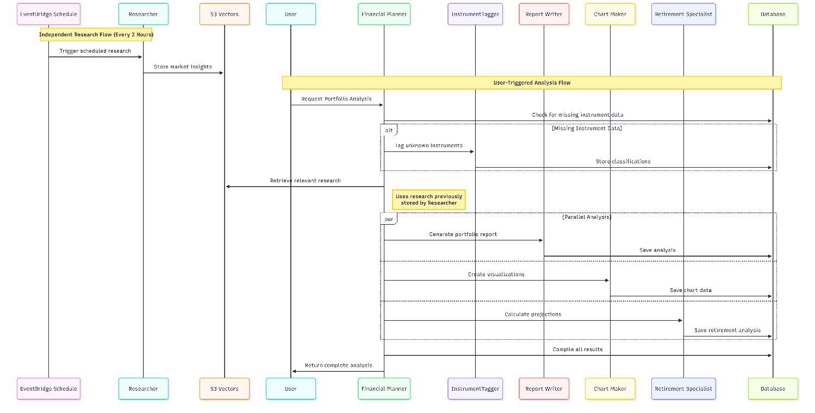

Data Flow
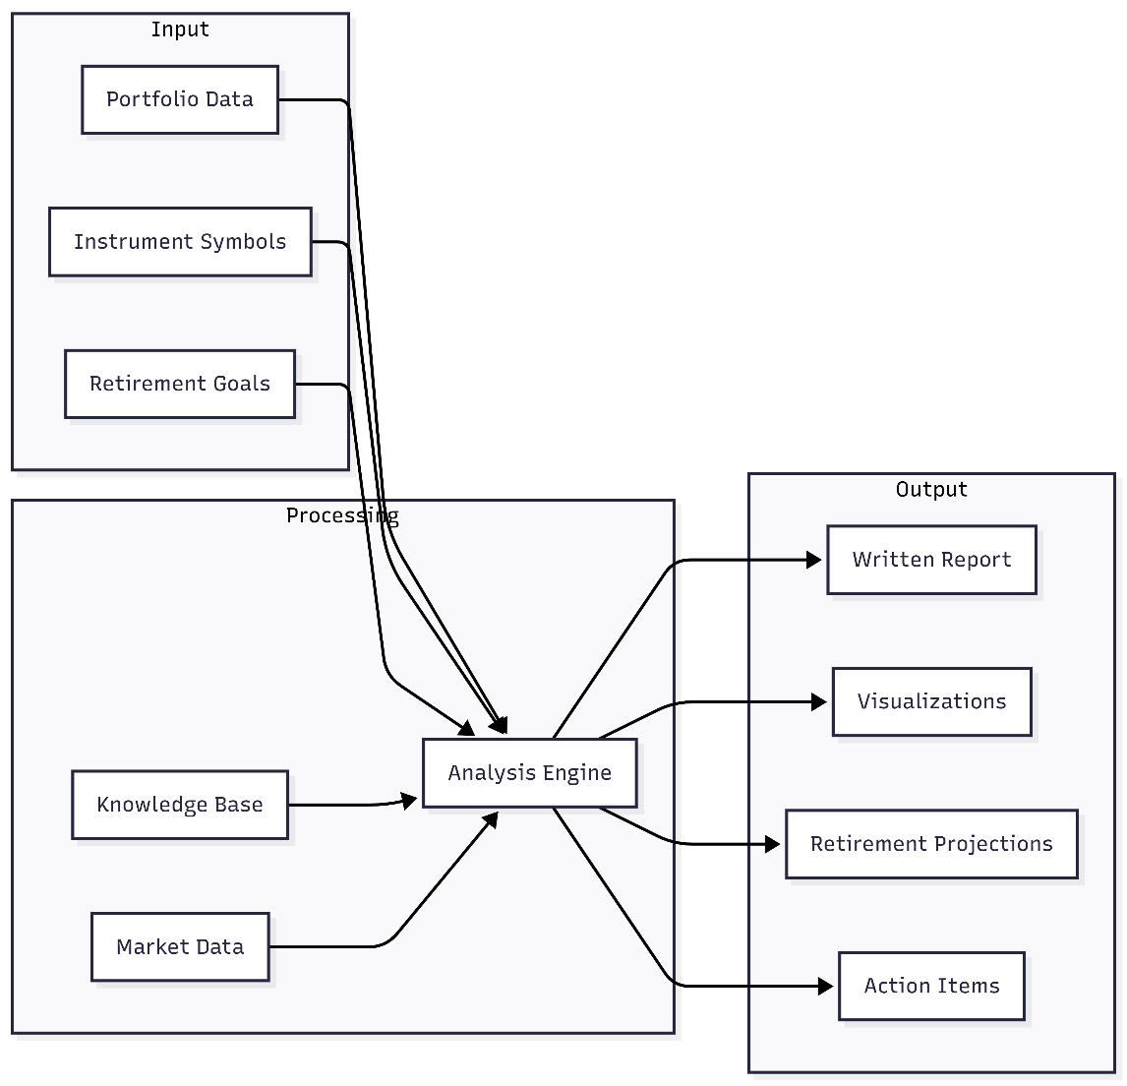

Knowledge Integration
The agents leverage two primary knowledge sources:
S3 Vectors Knowledge Base
- Historical research and market insights
- Company analysis and earnings reports
- Economic indicators and trends
- Investment strategies and recommendations
- Continuously updated by the Researcher agent
Database Reference Data
- Instrument classifications and allocations
- User portfolios and preferences
- Historical reports and analyses
- Cached calculations and projections

Key Design Principles
- Specialization: Each agent has a focused responsibility
- Orchestration: Financial Planner coordinates but doesn't micromanage
- Parallel Execution: Independent agents run simultaneously for speed
- Knowledge Sharing: S3 Vectors enables collective intelligence
- Graceful Degradation: System works even if some agents fail
- Incremental Enhancement: New agents can be added without disrupting existing ones

Note: 1. For architecture diagrams refer https://drive.google.com/file/d/1nfYtw7t4d_hWKO-fZkyMo7oEaTKWupyn/view?usp=sharing
2. Refer enterprise.md under guide folder to understand about scalability, security, monitoring, guardrails, explainability, and observability incorporation.

What problem are you solving? Why did you build it?
Alex is an AI-powered financial-planning SaaS application. It helps an investor understand a portfolio across accounts, see allocation and concentration risks, receive research-backed insights, and assess retirement readiness.
I built it because this analysis is normally fragmented across spreadsheets, broker dashboards, and generic market commentary. Alex combines the user’s holdings, preferences, market research, and retirement goals into one explainable analysis.
Why does it need AI?
The core calculations—portfolio values, allocations, and Monte Carlo simulations—are deterministic. AI is valuable for the parts that require judgment and communication:
- Classifying instruments and their exposures.
- Retrieving and synthesizing relevant market research.
- Turning portfolio data into a personalized written report.
- Selecting useful charts and producing frontend-ready chart JSON.
- Coordinating different specialist tasks.
AI does not replace financial facts or deterministic calculations; it makes the system adaptive, contextual, and easier for a user to understand.
What was your baseline?
The baseline was a conventional rules-and-dashboard approach:
- CRUD portfolio management in PostgreSQL.
- Fixed allocation calculations and static charts.
- Manual research or keyword search.
- A single generic report template.
That baseline is predictable and cheap, but it cannot tailor analysis well, retrieve semantically related research, or explain portfolio-specific trade-offs naturally. Alex retains deterministic data and validation while using AI for the higher-value reasoning layer.
How did you evaluate the results?
I evaluated it at several levels:
- Local tests with mocked dependencies for each of the five agents, then an end-to-end suite expecting all five to pass.
- Deployed tests for every Lambda agent, run repeatedly for reliability.
- End-to-end tests through SQS: create a job, process it, persist separate outputs, and mark it complete.
- Scenario tests with multiple accounts and five simultaneous users.
- Output checks: valid instrument classifications, charts matching the expected JSON schema, complete report sections, and retirement outputs with sensible probability/projection fields.
- Operational checks in CloudWatch and LangFuse: durations, token usage, failures, tool calls, retries, and traces.
A good interview point: I would not claim a single “AI accuracy” percentage without a labelled financial-advice benchmark. The evaluation is a combination of correctness of structured outputs, workflow completion, retrieval relevance, and expert/human review of recommendations.
What happens when the system fails?
Failures are designed to be visible and recoverable:
- API inputs are authenticated with Clerk JWTs and validated with Pydantic before processing.
- The request is stored as a job, then placed on SQS, so the user request is decoupled from long-running agent work.
- Transient failures such as throttling and timeouts retry with exponential backoff.
- Failed queue messages move to a dead-letter queue after retries for investigation and replay.
- Each specialist writes only to its own JSONB result field, avoiding corrupted merges.
- The planner marks a job complete only after required work succeeds; errors are recorded on the job.
- CloudWatch alarms/logs and LangFuse traces provide the debugging trail.
- Guardrails validate structured outputs—for example chart JSON—and return a safe fallback rather than rendering malformed content.
The UI can therefore show a pending or failed job state instead of pretending analysis succeeded.
What are the latency and cost?
For the current project configuration:
- Standard portfolio API operations are typically seconds or less, excluding cold starts.
- A full multi-agent analysis normally takes about 90–120 seconds.
- The independent specialist agents run in parallel, which is much faster than sequential execution.
- On-demand research generally takes 20–30 seconds because it browses and synthesizes sources.
- The SageMaker serverless embedding endpoint can have a 10–60 second cold start; warm requests are much faster.
Development cost is roughly $50–70/month, with Aurora Serverless v2 as the largest fixed cost at about $43–60/month. Lambda, SQS, API Gateway, S3, and CloudFront are low-volume, pay-per-use services. Bedrock is usage-based, estimated in the guide at roughly $0.01–0.10 per analysis. S3 Vectors was selected as a lower-cost alternative to OpenSearch for vector retrieval.

Explain the end-to-end architecture and request flow
Browser
→ CloudFront
→ S3-hosted Next.js frontend
→ API Gateway
→ FastAPI Lambda
→ Aurora Serverless v2 / SQS

SQS
→ Planner Lambda
→ Tagger, Reporter, Charter, Retirement Lambdas
→ Aurora job result fields
→ API Lambda
→ Frontend polls job status and renders results
More specifically:
- The user signs in through Clerk.
- The Next.js frontend sends a JWT-authenticated request through API Gateway.
- The API Lambda validates the token and input, reads/writes portfolio data through Aurora’s Data API, creates an analysis job, and submits the job ID to SQS.
- SQS invokes the Planner Lambda.
- The Planner loads the user’s portfolio and preferences. If instrument metadata is incomplete, it invokes the Tagger.
- The Planner invokes the Reporter, Charter, and Retirement agents in parallel.
- The Reporter can retrieve relevant research from S3 Vectors. That research is created by a separate Researcher service, embedded through SageMaker, and indexed in S3 Vectors.
- Each agent stores its own output in Aurora: report markdown, chart JSON, retirement projection, and planner summary.
- The frontend polls the job endpoint, then renders the report, Recharts visualizations, and retirement view once the job is complete.

How are the agents connected?
They are not connected through uncontrolled agent-to-agent chat. The Planner is the orchestrator and controls delegation.
- Planner → Tagger, when classifications are missing.
- Planner → Reporter, Charter, and Retirement in parallel.
- Agents communicate through defined Lambda invocation contracts and shared persisted job state.
- Each specialist has a narrow responsibility and an isolated output field.
- The Planner coordinates completion and produces the final summary.
This makes the system easier to test, observe, and change than a free-form conversation among agents.

Why did you choose this architecture?
I chose a serverless, event-driven architecture because portfolio analysis is bursty and long-running:
- SQS absorbs bursts and decouples the user request from agent processing.
- Lambda scales individual agents independently and avoids always-on compute.
- Aurora PostgreSQL fits relational portfolio data and provides SQL plus JSONB for flexible agent outputs.
- Aurora Data API avoids persistent database connections and simplifies Lambda networking.
- S3 Vectors enables lower-cost semantic retrieval.
- CloudFront + S3 makes the frontend fast and inexpensive.
- Clerk removes the need to build authentication infrastructure from scratch.

Can you explain the trade-offs?
- Multi-agent vs one agent: better specialization, parallelism, and maintainability, but more orchestration, observability, and failure modes.
- Lambda vs always-on services: low idle cost and automatic scale, but cold starts and execution-time constraints.
- Asynchronous SQS jobs vs synchronous response: resilient and scalable, but the user waits and the frontend must handle job status.
- Aurora Serverless vs DynamoDB: SQL relationships and transactional integrity are ideal for accounts and positions, but Aurora has a meaningful minimum cost.
- S3 Vectors vs OpenSearch: significantly lower cost for retrieval, but fewer mature search/analytics features.
- Bedrock foundation model vs custom-trained model: faster to build and operate, but output quality depends on prompts, retrieval, guardrails, and model availability.
- Clerk vs self-managed identity: faster and more secure to implement, but introduces a third-party dependency.
What is multi-tenant in this project?
Multi-tenant means one deployed application serves many users while keeping their data logically separated.
In Alex:
- Clerk authenticates the user and provides a unique clerk_user_id.
- Accounts, positions, preferences, jobs, reports, charts, and retirement projections are associated with that user ID.
- Every authenticated API request uses the identity from the JWT, rather than trusting a user ID supplied by the browser.
- Shared instrument reference data is common to all tenants, but each user’s portfolio and generated analysis remain isolated.
This is logical tenancy in a shared Aurora database, not a separate database per customer.

